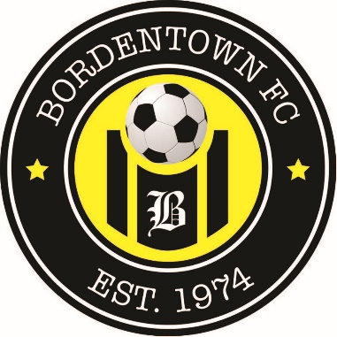

February 2021

Dear Student,
Bordentown FC (formerly BCSA) invites you to participate in the annual Friendship Scholarship Award. It is a monetary prize named after Friendship Field, the home of BFC soccer, built by the joint efforts of area communities. It is awarded to the student or students who best exemplify a balance of good sportsmanship, scholastic achievement and contributions to the local community.

Applicants must be a graduating senior, played in the Association in either recreational or travel program for at least three seasons, with intentions of continuing their education. Please fill out the application to the best of your ability. You may attach additional information if needed. Deadline is May 31, 2021. Please EMAIL your completed scholarship application to njbobafett@verizon.net with the subject line BFC Scholarship.

BFC is proud to have been a part of your development. Congratulations on your upcoming graduation and best wishes in your future endeavors.

Sincerely,

Bordentown FC
FRIENDSHIP SCHOLARSHIP APPLICATION

Submit by May 31, 2021

Please fill in all blanks on first page of application. Students can write or type answers to questions on application or attach answers if more space is necessary.
Name: __________________________________________DOB:__________________________
Address: _______________________City:___________State:___Zip:________Ph:___________
Email address:__________________________________________________________________
High School:___________________________________________________________________
Guidance Counselor:________________________________Graduation Date:_______________
School attending post graduation: __________________________________________________
# of Sibling/ages/schools attending______________________________________________
______________________________________________________________________________
Years Played Soccer in High School: _________________________________________________
Soccer Clubs:___________________________________________________________________
BFC years & coach names if recollected:____________________________________________ ______________________________________________________________________________
Athletic Awards:________________________________________________________________
Employment:___________________________________________________________________
______________________________________________________________________________
How do you plan on paying for college:______________________________________________
______________________________________________________________________________
______________________________________________________________________________
Any information you feel may be relevant that was not addressed:________________________
______________________________________________________________________________

Scholastic Background: Academic awards, Area/s of academic interest: ____________________________________________________________________________________________________________________________________________________________________________________________________________________________________________________________________________________________________________________________________________________

Community/School Involvement: Volunteerism, Extra-curricular activities, Hobbies: ______________ ____________________________________________________________________________________________________________________________________________________________________________________________________________________________________________________________________________________________________________________________________________________
What I have learned playing soccer and how I can apply that to my future: ______________________ ____________________________________________________________________________________________________________________________________________________________________________________________________________________________________________________________________________________________________________________________________________________
Most memorable soccer experience: ______________________________________________________ ____________________________________________________________________________________________________________________________________________________________________________________________________________________________________________________________________________________________________________________________________________________
What do you enjoy doing in your free time?_________________________________________________ ____________________________________________________________________________________ ____________________________________________________________________________________
Who do you cheer for during World Cup? __________________________________________________
____________________________________________________________________________________

Send to: njbobafett@verizon.net with the subject line BFC Scholarship
Please contact Mike Noble with any questions. 609.234.4600

